**How to Run Blood Bank (BBMS With ML) System**

1. First Run Flask Server file as python file with any Python IDE such as (“Pycharm , Visual Studio Code”)

Note : the path of dataset file must be the real file location (“real path”) in your device “Laptop or PC”

Example : “D:\\python\\uci-blood-transfusion-service-center\\transfusion.data.csv”.

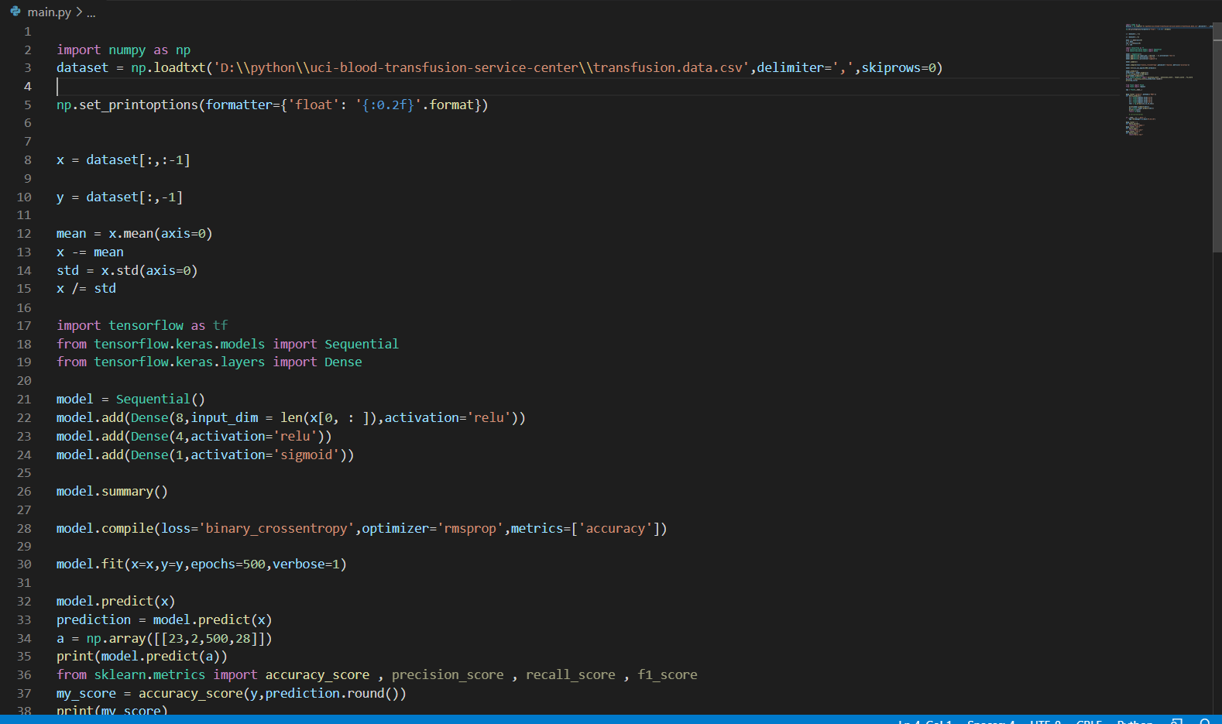

1. Second open Android Studio and open the two application folder’s as Click File > New > Import Project and import it from folder location .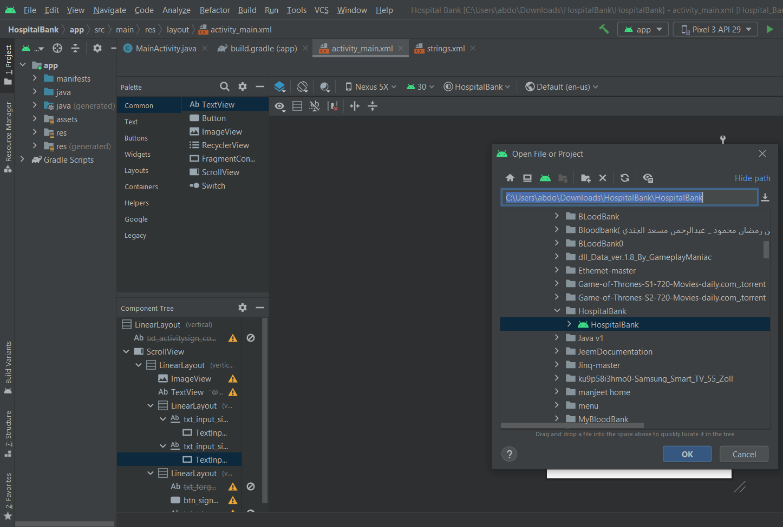
2. Run Hospital blood bank app ” APK” to connect with the server.
3. Sign in as Hospital blood bank with hospital email and password in Hospital

blood bank APK.

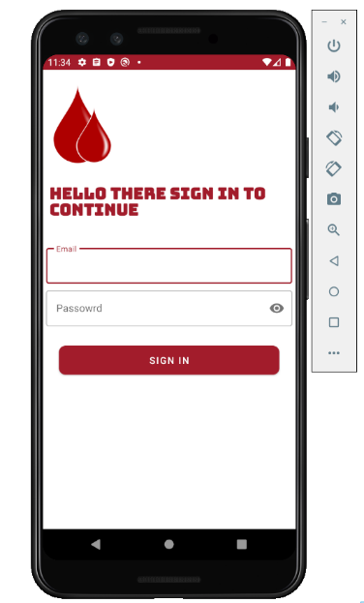

1. Run My blood bank app ”APK” to connect with Hospital blood bank app and server; and sign up if you have not any registered email or sign in with email and password; and if you have a registered email or use any tested application email’s which the android team was created (it’s location in users data folder).

